**Python Project Submission Sandhya**

**Git hub link: https://github.com/Sandhya-sam-99/Python-Project-Submission-Sandhya**

<https://amazon.awsapps.com/workdocs-amazon/index.html#/document/4cb5600db98a5164b8a53df853c40927131cbcb1c059ef5cc02fd1d5f9bfa05f>

Full automation with all the necessary dependency files will be saved in the above-mentioned link

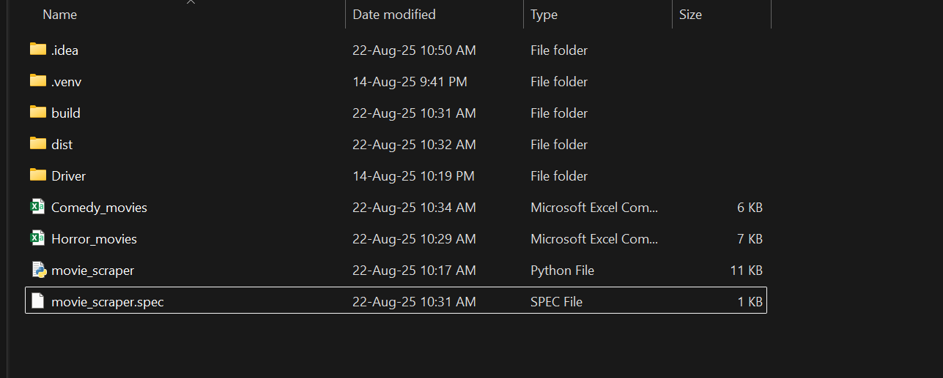

Movie scraper bot

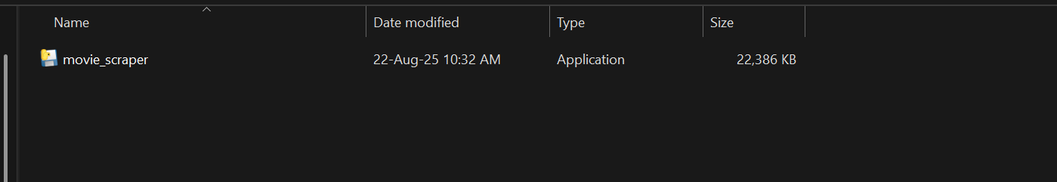

The complete video of how bot works

